WEEK 6:

Week 6.1: Build a REST API to add new products (POST) and get all products (GET). Return data in JSON format.
Thus we create a new class called Product:

package com.fsad;

import jakarta.persistence.*;

@Entity
@Table(name = "product")
public class Product {

@Id
@Column(name = "id")
private int id;

@Column(name = "name")
private String name;

@Column(name = "price")
private double price;

public Product() {}

public Product(int id, String name, double price) {
this.id = id;
this.name = name;
this.price = price;
}

public int getId() { return id; }
public String getName() { return name; }
public double getPrice() { return price; }
public void setId(int id) { this.id = id; }
public void setName(String name) { this.name = name; }
public void setPrice(double price) { this.price = price; }
}

Basically creating fields, entities using JPA like we did earlier.
Next, we made ProductRepository -> Interface:
package com.fsad;

import org.springframework.data.jpa.repository.JpaRepository;

public interface ProductRepository extends JpaRepository<Product, Integer> {
}

Creating ProductService -> Class:
package com.fsad;

import org.springframework.beans.factory.annotation.Autowired;
import org.springframework.stereotype.Service;
import java.util.List;

@Service
public class ProductService {

@Autowired
ProductRepository productRepository;

public Product saveProduct(Product product) {
return productRepository.save(product);
}

public List<Product> getAllProducts() {
return productRepository.findAll();
}

public Product getProductById(int id) {
return productRepository.findById(id).orElse(null);
}

public void deleteProduct(int id) {
productRepository.deleteById(id);
}

public Product updateProduct(int id, Product updatedProduct) {
updatedProduct.setId(id);
return productRepository.save(updatedProduct);
}
}

ProductController -> Class:
package com.fsad;

import org.springframework.beans.factory.annotation.Autowired;
import org.springframework.web.bind.annotation.*;
import java.util.List;

@RestController
@RequestMapping("/products")
public class ProductController {

@Autowired
ProductService productService;

@PostMapping
public Product addProduct(@RequestBody Product product) {
return productService.saveProduct(product);
}

@GetMapping
public List<Product> getAllProducts() {
return productService.getAllProducts();
}

@GetMapping("/{id}")
public Product getProductById(@PathVariable int id) {
return productService.getProductById(id);
}

@PutMapping("/{id}")
public Product updateProduct(@PathVariable int id, @RequestBody Product product) {
return productService.updateProduct(id, product);
}

@DeleteMapping("/{id}")
public String deleteProduct(@PathVariable int id) {
productService.deleteProduct(id);
return "Product deleted successfully!";
}
}

Now, we test it on POSTMAN:
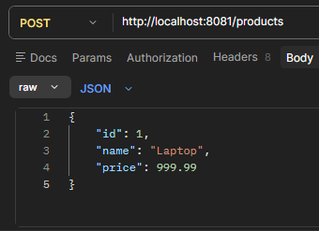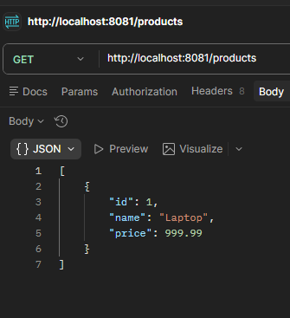
Task 6.2 Getting ById:
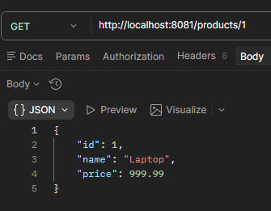
Task 6.3 Deleting ById:
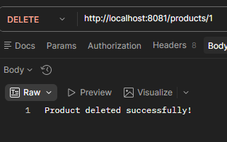

Task 6.4: This one wants us to demonstrate @RequestParam, @PathVariable, and @ResponseEntity with custom status codes.
First we add the following to ProductController:
Also, basically Params reads things like:
/products/search?name=Laptop
Which we haven’t encountered so far. So that is the new addition.
After @Autowired statement add this:
@GetMapping("/search")
public Product getByName(@RequestParam String name) {
List<Product> products = productService.getAllProducts();
for(Product p : products) {
if(p.getName().equalsIgnoreCase(name)) {
return p;
}
}
return null;}
Now testing again using POSTMAN:
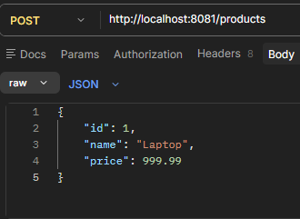
Now we use Params to see the output:
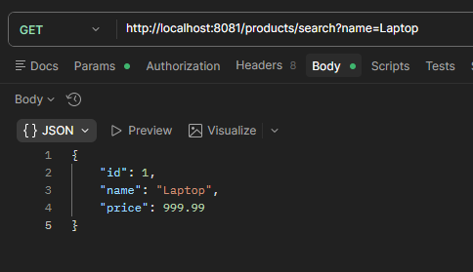

Task 6.5:
Three things:
- Bean Validation on /register
- Global Exception Handler with @ControllerAdvice
- JWT login endpoint

First we open pom.xml and add the following dependencies:
<dependency>
<groupId>org.springframework.boot</groupId>
<artifactId>spring-boot-starter-validation</artifactId>
</dependency>

<dependency>
<groupId>io.jsonwebtoken</groupId>
<artifactId>jjwt-api</artifactId>
<version>0.11.5</version>
</dependency>

<dependency>
<groupId>io.jsonwebtoken</groupId>
<artifactId>jjwt-impl</artifactId>
<version>0.11.5</version>
</dependency>

<dependency>
<groupId>io.jsonwebtoken</groupId>
<artifactId>jjwt-jackson</artifactId>
<version>0.11.5</version>
</dependency>

Now, we create a new class called User:
package com.fsad;

import jakarta.validation.constraints.*;

public class User {

@NotBlank(message = "Name must not be empty")
private String name;

@Email(message = "Must be a valid email")
private String email;

@Min(value = 18, message = "Age must be at least 18")
private int age;

public String getName() { return name; }
public String getEmail() { return email; }
public int getAge() { return age; }

public void setName(String name) { this.name = name; }
public void setEmail(String email) { this.email = email; }
public void setAge(int age) { this.age = age; }
}

Now we create a new class called GlobalExceptionHandler:
package com.fsad;

import org.springframework.http.HttpStatus;
import org.springframework.http.ResponseEntity;
import org.springframework.web.bind.MethodArgumentNotValidException;
import org.springframework.web.bind.annotation.ControllerAdvice;
import org.springframework.web.bind.annotation.ExceptionHandler;
import java.time.LocalDateTime;
import java.util.HashMap;
import java.util.Map;

@ControllerAdvice
public class GlobalExceptionHandler {

@ExceptionHandler(MethodArgumentNotValidException.class)
public ResponseEntity<Map<String, Object>> handleValidationErrors(
MethodArgumentNotValidException ex) {
Map<String, Object> response = new HashMap<>();
response.put("timestamp", LocalDateTime.now());
response.put("error", ex.getBindingResult()
.getFieldErrors()
.stream()
.map(e -> e.getField() + ": " + e.getDefaultMessage())
.toList());
return new ResponseEntity<>(response, HttpStatus.BAD_REQUEST);
}
}

NOTE:
@ControllerAdvice = a global safety net that catches errors from ALL controllers in one place. Instead of handling errors in every controller separately, you handle them all here!
@ExceptionHandler = "when THIS specific error happens, run this method"
MethodArgumentNotValidException = the error Spring throws when validation fails (like empty name, invalid email, age under 18)
So when someone sends invalid data to /register:
- Spring validates it
- Validation fails → throws MethodArgumentNotValidException
- @ControllerAdvice catches it
- Returns a nice JSON error response with timestamp and error message!
"@ControllerAdvice provides centralized exception handling across all controllers, returning structured error responses."

Now we create AuthController class:
package com.fsad;

import org.springframework.http.ResponseEntity;
import org.springframework.web.bind.annotation.*;
import jakarta.validation.Valid;
import java.util.Map;

@RestController
public class AuthController {

@PostMapping("/register")
public ResponseEntity<String> register(@Valid @RequestBody User user) {
return ResponseEntity.ok("User registered: " + user.getName());
}

@PostMapping("/login")
public ResponseEntity<String> login(@RequestBody Map<String, String> credentials) {
String username = credentials.get("username");
String password = credentials.get("password");
if("admin".equals(username) && "password".equals(password)) {
return ResponseEntity.ok("JWT-TOKEN-DUMMY-12345");
}
return ResponseEntity.status(401).body("Invalid credentials!");
}
}

NOTE:
/register endpoint:
- Takes a User object from request body
- @Valid triggers the validation rules we set in User class (@NotBlank, @Email, @Min)
- If validation fails → GlobalExceptionHandler catches it and returns error JSON
- If validation passes → returns success message!
/login endpoint:
- Takes username and password
- Checks if they match "admin" and "password" (dummy validation — real apps use database!)
- If correct → returns a fake JWT token
- If wrong → returns 401 Unauthorized!
"The /register endpoint validates user input using Bean Validation annotations. The /login endpoint authenticates credentials and returns a JWT token for authorization."
JWT in real life is a secure encrypted token that proves you're logged in — like a digital ID card!

Now we test again in POSTMAN:
http://localhost:8081/register
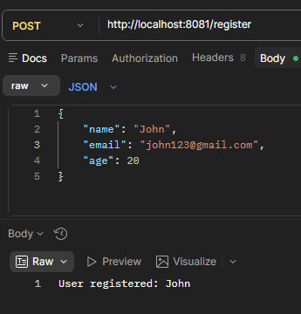
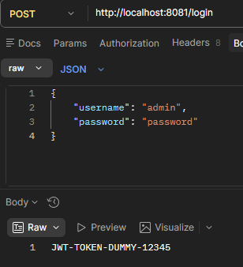

Invalid credentials:
